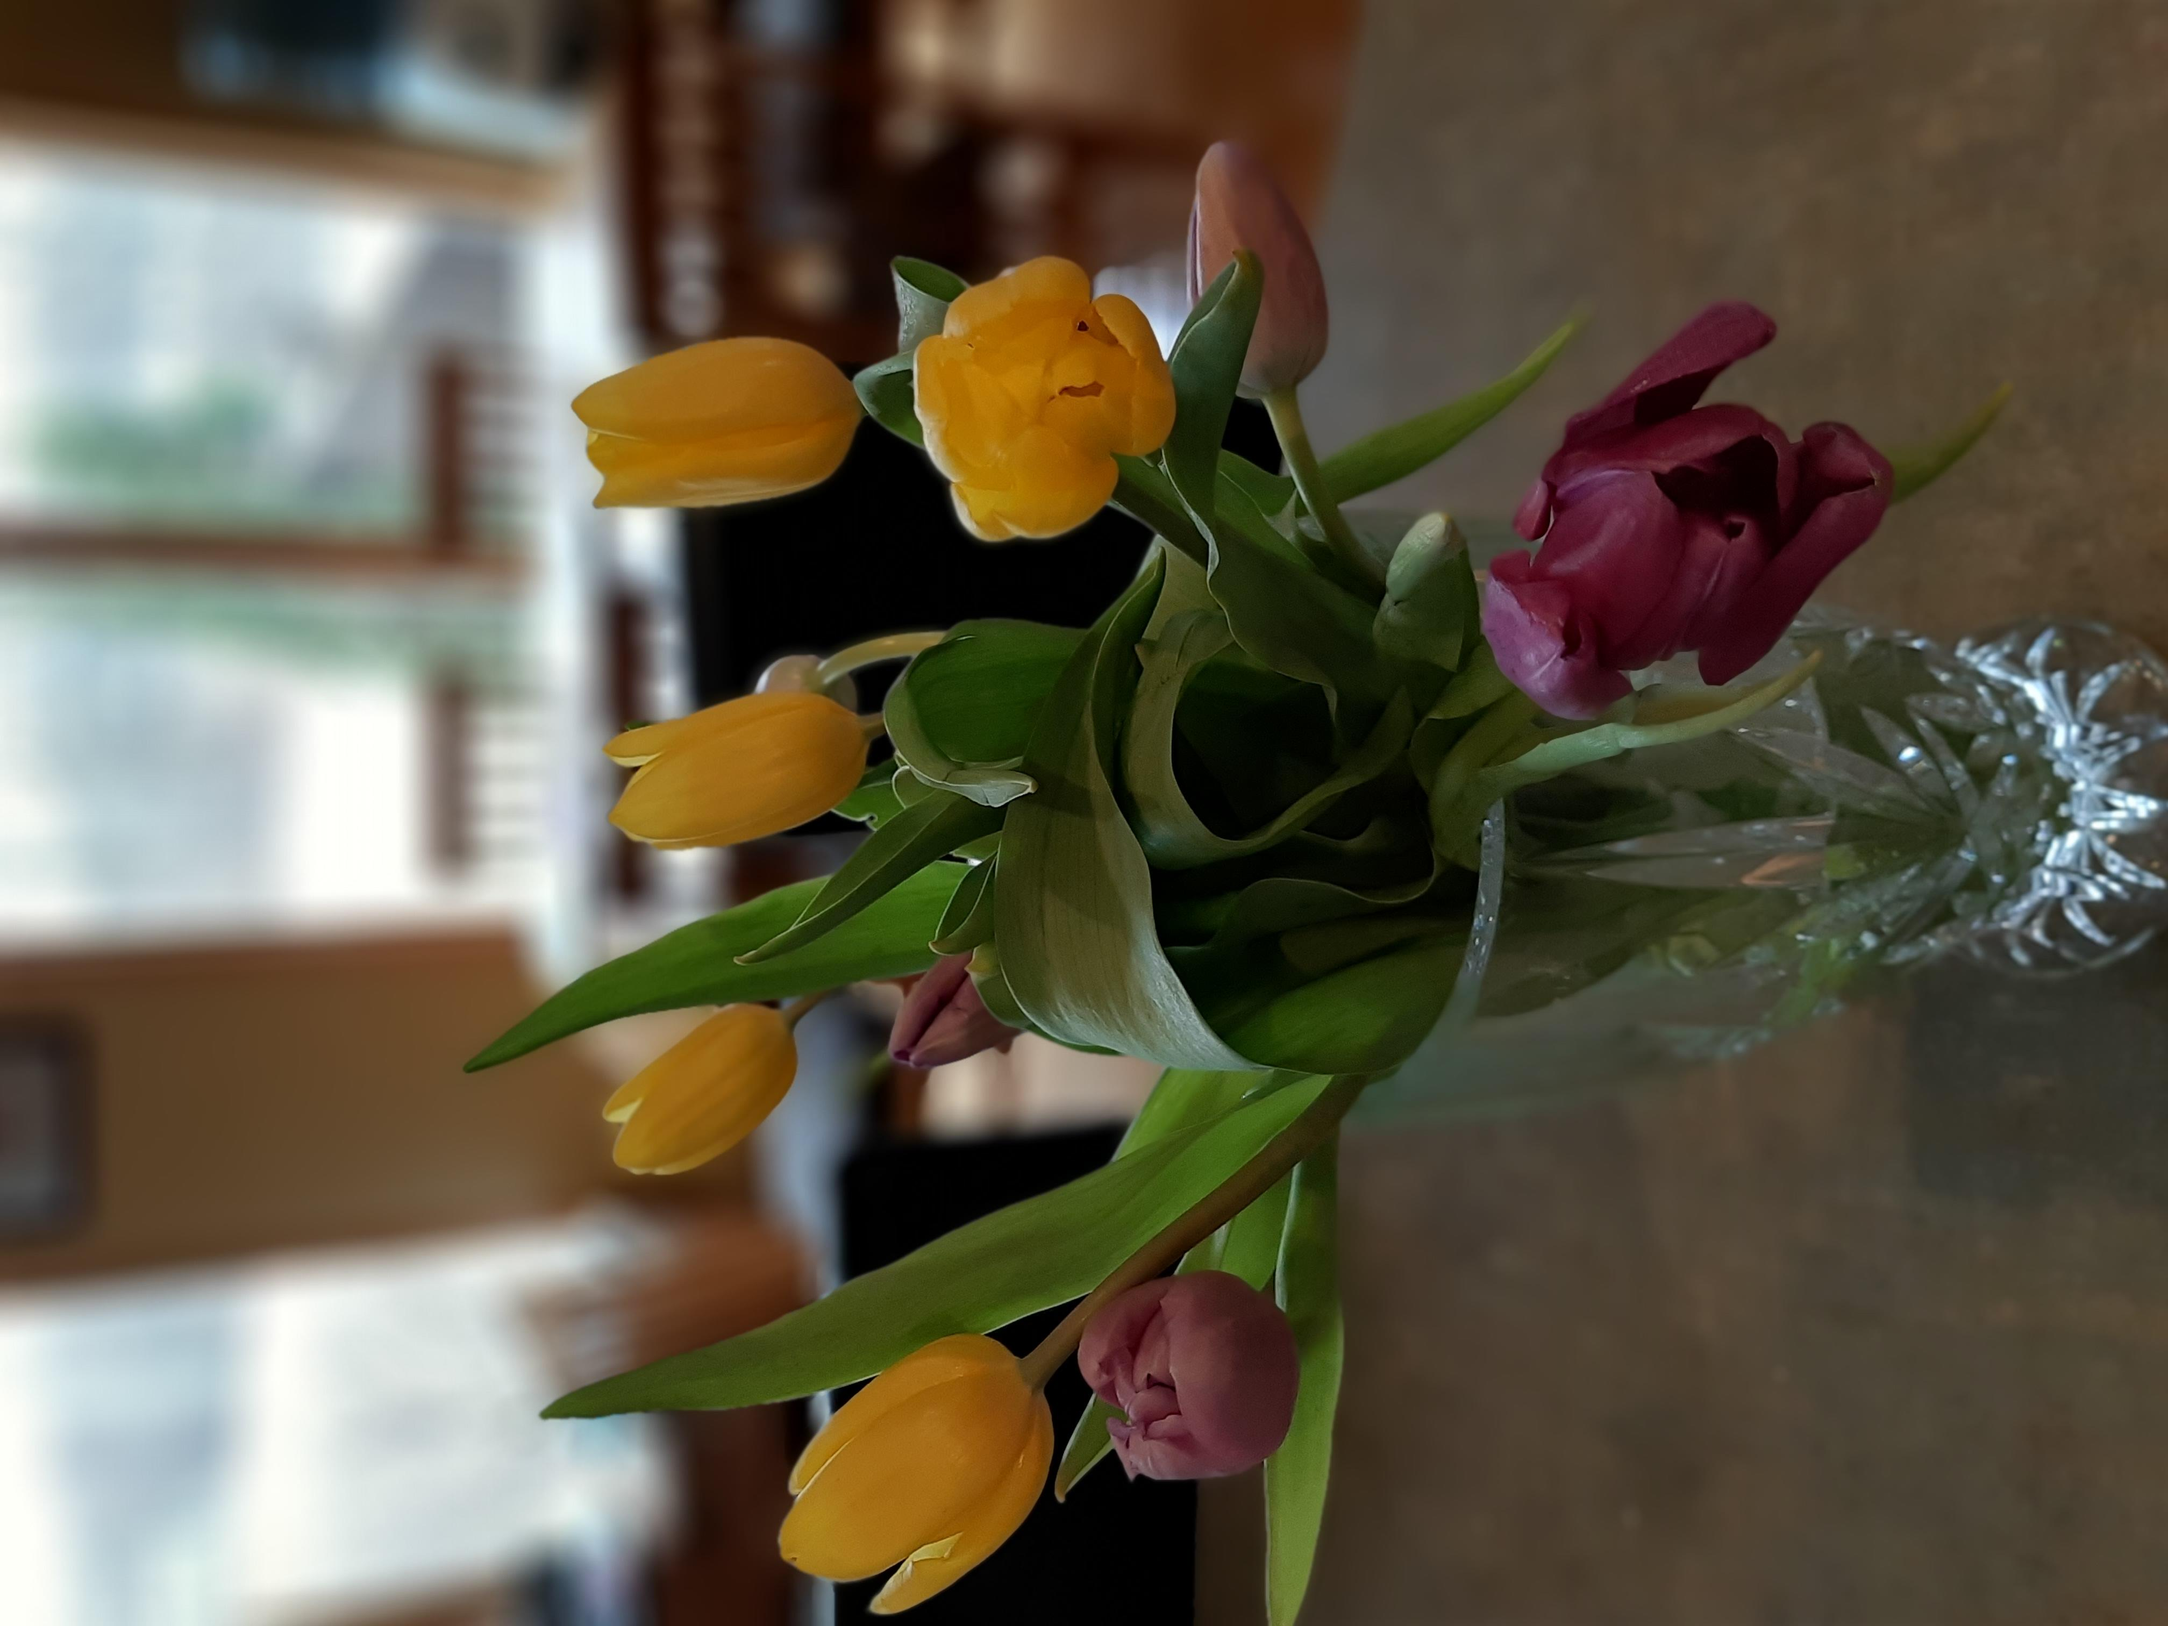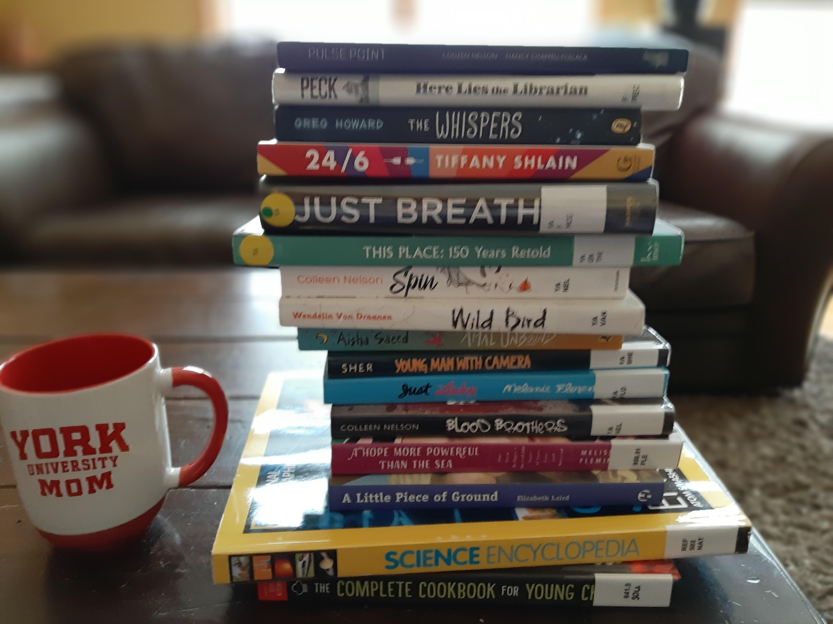

Hello ESMS Students and Families!

I am sure the combination of living in isolation and mother nature not wanting to release the grips of winter, has got us all feeling a little cabin fever and going a little squirrely. But what better way to escape reality for a little while and pick up a book or a magazine!

I am working on developing a webpage for our library, so that we can share what we have been reading and book recommendations/reviews. But in the meantime, I thought I would reach out and say hello and give you some information on some online resources you can check out, if you have exhausted your books at home.

Missing you all and hope this finds you all well!

Mrs. Stewart

## Covid-19 Reading

## Survival Guide

**Reading Resources**

Different sites and links that you can access books and interesting things to read online.

Inside

East Selkirk

Middle School

Library

From my living room to yours…

April 17, 2020

“A book is a gift you can open again and again”

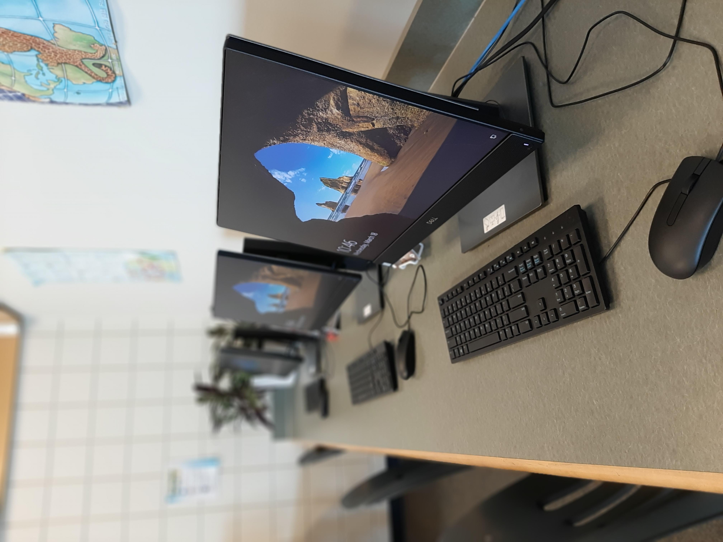

* Scholastic Choices Magazine: choices.scholastic.com password: timefrog429
* Contact Gaynor Regional Family Library and download their ‘Libby’ app to access free online e-books. Their phone number is (204) 482-3522 and they would be happy to help.
* EPIC Books: getepic.com
* CBC Kids News: cbc.ca/kidsnews/
* Instagram has this neat page called #SavewithStories, that has famous people reading beloved children’s stories
* Youtube also has different authors reading excerpts from their books: one example is Kenneth Oppel, author of Silverwing, The Nest, Bloom, Airborn, The Boundless, Inkling and many others
* Webpath Express which can be located on our school library platform – an online encyclopedia of information that is trustworthy and reliable

These are just a few suggestions. If you find any others and would like to share them with me, feel free to contact me at [tstewart@lssd.ca](mailto:tstewart@lssd.ca). I would love to hear from you!

Online Reading

### While we can’t visit our school and local libraries, here are some suggestions: